**Gender Equality and Anti-Discrimination Committee**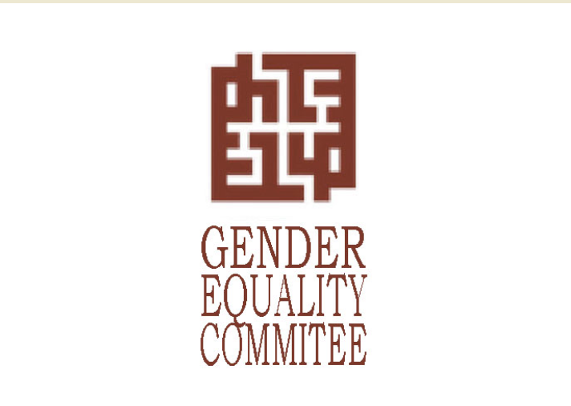

[The Gender Equality and Anti-Discrimination Committee](https://www.eif.uoc.gr/index.php/en) serves as an advisory body to the University of Crete and its administrative authorities. Its mission is to promote gender equality and combat discrimination based on gender, racial or ethnic origin, religion or beliefs, health status/disability, age, or sexual orientation across all operational levels and in all processes and activities of academic life. The Committee works to prevent and address all forms of discrimination, sexism, and any form of harassment at the University of Crete.

The G.E.A.D.C. is tasked with providing mediation services in cases of complaints about discriminatory treatment or harassing behavior and offering assistance to victims of discrimination when they [report](https://www.eif.uoc.gr/index.php/en/2021-06-03-10-01-en/2021-06-03-11-03-38nen) such treatment.

Members of the Committee are obligated to maintain confidentiality and privacy regarding any information they become aware of during the investigation and handling of reports. Any member of the academic community (students, faculty members, teaching staff, laboratory staff, administrative staff, and other employees at the University of Crete) can [submit a report](https://www.eif.uoc.gr/index.php/en/2021-06-03-10-01-en/2021-06-03-11-03-38nen) to the G.E.A.D.C. about incidents of discrimination based on gender, sexual harassment/gender-based violence, or power-based violence. It should be noted that the G.E.A.D.C. accepts reports from individuals who have either experienced any such behavior themselves or have witnessed such incidents.